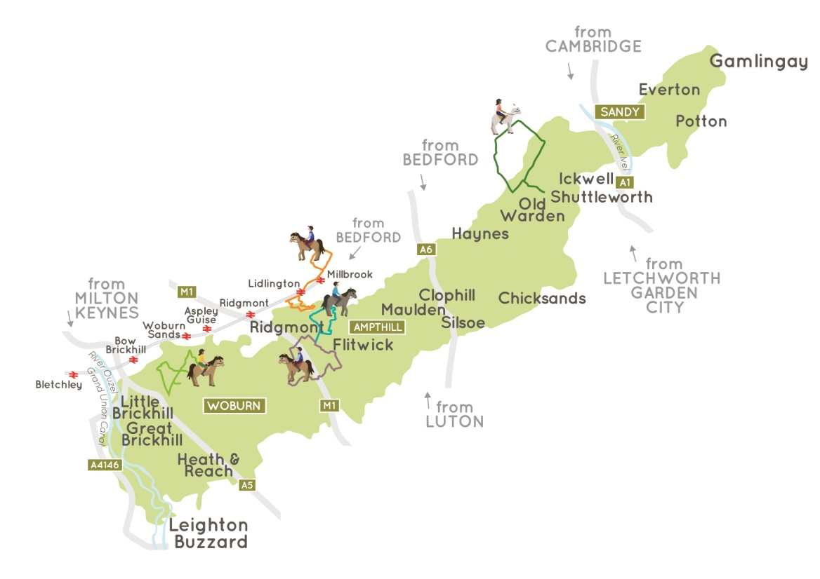
GREENSAND COUNTRY HORSERIDING LEAFLETS – ORDER FORM
(Please email completed form to bhs.beds@gmail.com)
Please indicate which leaflets you would like …
All 6 leaflets (inc overview) |  | All 5 route leaflets only
Overview (includes accommodation information) |  | Aspley (light green route on map above)
Bluebell (purple) |  | Warren (blue)
Brick (orange) |  | Assarts (dark green) – currently temporarily closed due to badger holes
Your name and address (in a format that can be copied and pasted to an address label please)

Please send payment for postage and packing to
Sort code 60-83-01 Acct 20380276
BHS Bedfordshire
1 or 2 leaflets: £1.05 (first) or £0.86 (2nd)
More leaflets: £2.20 (first) or £1.90 (2nd)

A donation to BHS Access work would be welcomed!
Registered Charity Nos. 210504 and SC038516

